
YEDITEPE UNIVERSITY FACULTY OF MEDICINE DEPARTMENT OF INTERNAL MEDICINE
PHASE IV CLINICAL CLERKSHIP STUDENT PORTFOLIO
2025–2026
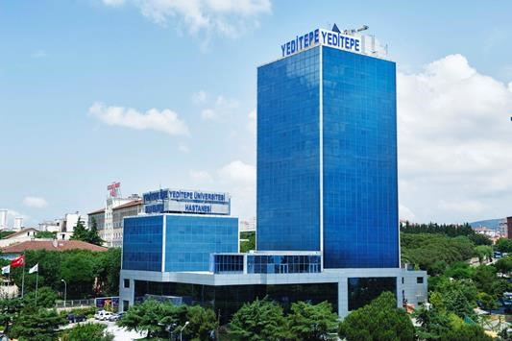

TABLE OF CONTENTS
- Units and faculty members implementing the training program
- Purpose and learning objectives of the Internal Medicine clerkship
- Assessment and evaluation section
- History Taking and Physical Examination Form
- Phase 4 clerkship evaluation form
TIPE.P.01-F.07 Rev 8, 12.10.2022

UNITS AND FACULTY MEMBERS IMPLEMENTING THE TRAINING PROGRAM
The Internal Medicine Clinical Clerkship will be conducted under the administration of the Yeditepe University Hospital Internal Medicine Clerkship Committee, using the facilities of two institution:
• Yeditepe University Hospital Internal Medicine Clinic -Theoretical sessions
Hospitals:Haydarpaşa Numune Training and Research Hospital – bedside history taking and physical examination practice
Phase IV Coordinator Asst. Prof. Dr. Burçin Yorgancı Kale
Head of the Department of Internal Medicine: Prof. Dr. Müge BIÇAKCIGİL KALAYCI
Department of Internal Medicine Phase IV education coordinator : Prof. Dr. Figen ATALAY
Prof. Dr. Serkan ÇELİK
DISCIPLINE | FACULTY
ENDOCRINOLOGY | Fahrettin KELEŞTEMUR, MD Prof.  Özlem HALİLOĞLU, MD Assoc. Prof.  Funda ÖZTÜRK, MD Lecturer
GASTROENTEROLOGY | Cengiz PATA, MD Prof.  Meltem ERGÜN, MD Prof.
HEMATOLOGY | Elif BİRTAŞ ATEŞOĞLU, MD Prof.  Figen ATALAY, MD Prof.
INTERNAL MEDICINE | Yaşar KÜÇÜKARDALI, MD Prof.  Mehmet Akif Öztürk, MD Assisted Prof.
MEDICAL ONCOLOGY | Bala Başak ÖVEN, MD Prof.  Serkan ÇELİK, MD Assoc. Prof.
RESPIRATORY SYSTEM | Banu Musaffa SALEPÇİ, MD Prof.  Seha AKDUMAN, MD,  Çelik SÜMER, MD Lecturer
NEPHROLOGY | Gülçin KANTARCI, MD Prof.  Abdullah ÖZKÖK, MD Prof.
RHEUMATOLOGY | Müge BIÇAKÇIGİL KALAYCI, MD Prof.
HAYDARPAŞA NUMUNE RESEARCH&EDUCATİON HOSPİTAL, INTERNAL MEDICINE CLINIC HOSPITAL (HAYDARPAŞA NUMUNE RESEARCH&EDUCATİON HOSPİTAL, INTERNAL MEDICINE CLINIC) | Refik DEMİRTUNÇ, MD Prof.  Funda TÜRKMEN, MD Prof.

PHASE 4 ACADEMIC SCHEDULE 2025 – 2026

TRANSITION TO CLINICAL SETTINGS (3 DAYS ) 03.09.202- 05.09.2025
CLINICAL ETHICS (1 WEEK) 08.09.2025- 12.09.2025
PUBLIC HEALTH (1 WEEK) 15.09.2025-19.09.2025
GROUP A | GROUP B | GROUP C | GROUP D
 |  | CARDIOLOGY (2 WEEKS) 22.09.2025-03.10.2025 | GENERAL SURGERY (4 WEEKS) 22.09.2025-17.10.2025
 |  | THEORETICAL: YEDİTEPE UNIVERSITY HOSPITAL - | THEORETICAL: YEDİTEPE UNIVERSITY HOSPITAL
 |  | PRACTICAL: KARTAL KOŞUYOLU HIGHER EDUCATION AND RESEARCH | PRACTICAL: İSTANBUL TRAINING AND RESEARCH HOSPITAL
 |  | HOSPITAL
INTERNAL MEDICINE (9 WEEKS) 22.09.202521.11.20245 |  | CARDIOVASCULAR SURGERY (2 WEEKS) 06.10.2025-17.10.2025
THEORETICAL: YEDİTEPE UNIVERSITY HOSPITAL | CHILD HEALTH AND PEDIATRICS (10 WEEKS ) | THEORETICAL: YEDİTEPE UNIVERSITY HOSPITAL -
PRACTICAL:HAYDARPAŞA NUMUNE TRAINING AND RESEARCH HOSPITAL | 22.09.2025-28.11.2025 | PRACTICAL: KARTAL KOŞUYOLU HIGHER EDUCATION AND RESEARCH
 | THEORETICAL: YEDİTEPE UNIVERSITY HOSPITAL | HOSPITAL
 | PRACTICAL:İSTANBUL TRAINING AND RESEARCH HOSPITAL.
 |  | GENERAL SURGERY (4 WEEKS) 20.10.2025-14.11.2025 | CARDIOLOGY (2 WEEKS) 20.10.2025-31.10.2025
 |  | THEORETICAL: YEDİTEPE UNIVERSITY HOSPITAL | THEORETICAL: YEDİTEPE UNIVERSITY HOSPITAL - PRACTICAL: KARTAL KOŞUYOLU HIGHER EDUCATION AND RESEARCH
 |  | PRACTICAL: İSTANBUL TRAINING AND RESEARCH HOSPITAL
ELECTIVE CLERCKSHİP (1 WEEK) 24.11.2025-28.11.2025 |  |  | EMERGENCY MEDICINE (2 WEEKS) 03.11.2025 -14.11.2025
ELECTIVE CLERCKSHİP (1 WEEK) 24.11.2025-28.11.2025 |  |  | YEDİTEPE UNIVERSITY HOSPITAL
 |  | EMERGENCY MEDICINE (2 WEEKS) 17.11.2025-28.11.2025
 |  | YEDİTEPE UNIVERSITY HOSPITAL
CHILD HEALTH AND PEDIATRICS (10 WEEKS ) | INTERNAL MEDICINE (9 WEEKS) 01.12.2024-30.01.2026 | PLASTIC, RECONSTRUCTIVE & AESTHETIC SURGERY (1,5 WEEK) 01.12.2025- | OBSTETRICS AND GYNECOLOGY (5 WEEKS) 17.11.2025- 19.12.2025
01.12.2025-06.02.2026 | THEORETICAL: YEDİTEPE UNIVERSITY HOSPITAL | 09.12.2025 YEDİTEPE UNIVERSITY HOSPITAL | THEORETICAL: YEDİTEPE UNIVERSITY HOSPITAL
THEORETICAL: YEDİTEPE | PRACTICAL: HAYDARPAŞA NUMUNE TRAINING AND RESEARCH HOSPITAL |  | PRACTICAL: SANCAKTEPE ŞEHİT PROF. DR. İLHAN VARANK TRAINING AND RESEARCH HOSPITAL
UNIVERSITY HOSPITAL
PRACTICAL: İSTANBUL TRAINING AND RESEARCH HOSPITAL. |  | THORACIC SURGERY (1,5 WEEK) 10.12.2025-19.12.2025
HOSPITAL |  | SÜREYYAPAŞA THORACIC DISEASES AND THORACIC SURGERY TRAINING AND RESEARCH HOSPITAL
 | ELECTIVE CLERCKSHİP (1 WEEK) 02.02.2026- |  | THORACIC SURGERY (1,5 WEEK) 22.12.2025-30.12.2025
 | 6.02.2026 |  | SÜREYYAPAŞA THORACIC DISEASES AND THORACIC SURGERY TRAINING AND RESEARCH HOSPITAL
CARDIOLOGY (2 WEEKS) 09.02.2026-20.02.2026 | GENERAL SURGERY (4 WEEKS) 09.02.2026-06.03.2026 | OBSTETRICS AND GYNECOLOGY (5 WEEKS) 22.12.2025-23.01.2026 | PLASTIC, RECONSTRUCTIVE & AESTHETIC SURGERY (1,5 WEEK) 31.12.2025-
THEORETICAL: YEDİTEPE UNIVERSITY HOSPITAL - | THEORETICAL: YEDİTEPE UNIVERSITY HOSPITAL | THEORETICAL: YEDİTEPE UNIVERSITY HOSPITAL | 9.01.2026
PRACTICAL: KARTAL KOŞUYOLU HIGHER EDUCATION AND RESEARCH | PRACTICAL: İSTANBUL EĞİTİM VE ARAŞTIRMA TRAINING AND RESEARCH HOSPITAL | PRACTICAL: SANCAKTEPE ŞEHİT PROF. DR. İLHAN VARANK TRAINING AND RESEARCH HOSPITAL | YEDİTEPE UNIVERSITY
HOSPITAL |  |  | HOSPITAL
CARDIOVASCULAR SURGERY (2 WEEKS) 23.02.2026-06.03.2026 |  |  | CARDIOVASCULAR SURGERY (2 WEEKS) 12.01.2026-23.01.2026
THEORETICAL: YEDİTEPE UNIVERSITY HOSPITAL - |  |  | THEORETICAL: YEDİTEPE UNIVERSITY HOSPITAL -
PRACTICAL: KARTAL KOŞUYOLU HIGHER EDUCATION AND RESEARCH |  |  | PRACTICAL: KARTAL KOŞUYOLU HIGHER EDUCATION AND RESEARCH
HOSPITAL |  |  | HOSPITAL
GENERAL SURGERY (4 WEEKS) 09.03.2026 -10.04.2026 | CARDIOLOGY (2 WEEKS) 09.03.2026 -27.03.2026
THEORETICAL: YEDİTEPE UNIVERSITY HOSPITAL | THEORETICAL: YEDİTEPE UNIVERSITY HOSPITAL - | INTERNAL MEDICINE (9 WEEKS) 26.01.2026-03.04.2026 THEORETICAL: YEDİTEPE UNIVERSITY HOSPITAL
PRACTICAL: İSTANBUL EĞİTİM VE ARAŞTIRMA TRAINING AND RESEARCH | PRACTICAL: KARTAL KOŞUYOLU HIGHER EDUCATION AND RESEARCH
 | HOSPITAL
HOSPITAL | CARDIOVASCULAR SURGERY (2 WEEKS)30.03.2026-10.04.2026 | PRACTICAL:HAYDARPAŞA NUMUNE TRAINING AND RESEARCH HOSPITAL + | CHILD HEALTH AND PEDIATRICS (10 WEEKS ) 26.01.2026-10.04.2026 THEORETICAL: YEDİTEPE
HOSPITAL | THEORETICAL: YEDİTEPE UNIVERSITY HOSPITAL - | PRACTICAL:HAYDARPAŞA NUMUNE TRAINING AND RESEARCH HOSPITAL + | UNIVERSITY HOSPITAL
HOSPITAL | PRACTICAL: KARTAL KOŞUYOLU HIGHER EDUCATION AND RESEARCH | PRACTICAL:HAYDARPAŞA NUMUNE TRAINING AND RESEARCH HOSPITAL + | PRACTICAL: İSTANBUL
HOSPITAL | HOSPITAL | PRACTICAL:HAYDARPAŞA NUMUNE TRAINING AND RESEARCH HOSPITAL + | ARAŞTIRMA TRAINING AND RESEARCH HOSPITAL
EMERGENCY MEDICINE (2 WEEKs) 13.04.2026-24.04.2026 YEDİTEPE |  | ELECTIVE CLERCKSHİP (1 WEEK) 06.04.2026-
UNIVERSITY HOSPITAL |  | 10.04.2026
PLASTIC, RECONSTRUCTIVE & AESTHETIC SURGERY (1,5 WEEKS) - | OBSTETRICS AND GYNECOLOGY (5 WEEKS) 13.04.2026-15.05.2026 THEORETICAL: YEDİTEPE UNIVERSITY HOSPITAL
27.04.2026-06.05.2026 YEDİTEPE UNIVERSITY HOSPITAL /8 gün | PRACTICAL: SANCAKTEPE ŞEHİT PROF. DR. İLHAN VARANK TRAINING AND RESEARCH HOSPITAL
THORACIC SURGERY (1,5 WEEKS) -07.05.2026-15.05.2026 |  |  | INTERNAL MEDICINE (9 WEEKS)
SÜREYYAPAŞA THORACIC DISEASES AND THORACIC SURGERY TRAINING AND RESEARCH HOSPITAL |  |  | 13.04.2026- 19.06.2026
 | THORACIC SURGERY (1,5 WEEK) 18.05.2026-03.06.2026 | CHILD HEALTH AND PEDIATRICS (10 WEEKS ) | THEORETICAL: YEDİTEPE UNIVERSITY HOSPITAL
 | SÜREYYAPAŞA THORACIC DISEASES AND THORACIC SURGERY TRAINING AND RESEARCH HOSPITAL | 13.04.2026-26.06.2026 THEORETICAL: YEDİTEPE UNIVERSITY HOSPITAL | PRACTICAL:HAYDARPAŞA NUMUNE TRAINING AND RESEARCH HOSPITAL
 |  | PRACTICAL: İSTANBUL TRAINING AND RESEARCH HOSPITAL
OBSTETRICS AND GYNECOLOGY (5 WEEKS) 18.05.2026-26.06.2026 | PLASTIC, RECONSTRUCTIVE & AESTHETIC SURGERY (1,5 WEEK)
THEORETICAL: YEDİTEPE UNIVERSITY HOSPITAL | 04.06.2026-.12.06.2026
PRACTICAL: SANCAKTEPE ŞEHİT PROF. DR. İLHAN VARANK TRAININGAND RESEARCH HOSPITAL | YEDİTEPE UNIVERSITY HOSPITAL
 | EMERGENCY MEDICINE (2 WEEKS) 15.06.2026-26.06.2026 |  | ELECTIVE CLERCKSHİP (1 WEEK) 22.06.2026-26.06.2026
 | YEDİTEPE UNIVERSITY HOSPITAL |  | ELECTIVE CLERCKSHİP (1 WEEK) 22.06.2026-26.06.2026

PURPOSE AND LEARNING OBJECTIVES OF THE INTERNAL MEDICINE CLERKSHIP
At the end of the Internal Medicine clerkship, students demonstrate an approach to the healthy and ill adult patient, adopt preventive health services, establish the diagnosis and differential diagnosis of diseases seen in adults, provide appropriate treatment at the primary care level, and ensure appropriate referral conditions and refer eligible patients to a higher-level healthcare center.
Learning Objectives:
Knowledge:
- Demonstrates knowledge of history taking and communication techniques.
- Demonstrates knowledge of a complete physical examination covering all organ systems.
- Demonstrates knowledge of disease diagnosis and differential diagnosis, and of the indications for and methods of emergency treatment.
- Demonstrates knowledge of diagnostic methods (laboratory techniques, imaging modalities, and other invasive or non-invasive procedures).
- Demonstrates knowledge of minor medical procedures and practices (blood sampling, intramuscular and intravenous injections, catheter insertion, fingertip blood glucose measurement, ECG recording, etc.).
- Demonstrates knowledge of legal responsibilities related to informing patients and their relatives and obtaining consent.
- Demonstrates knowledge of the indications for and methods of requesting consultations.
- Demonstrates knowledge of evidence-based medical practice in Internal Medicine.
Skills:
- Performs a detailed inquiry into the causes of complaints.
- Performs a complete physical examination covering all organ systems.
- Lists possible diagnoses and formulates a differential diagnosis.
- Uses diagnostic methods (laboratory techniques, imaging modalities, and other invasive or non-invasive procedures) accurately and cost-effectively.
- Interprets the results of these methods accurately.
- Distinguishes emergency from non-emergency conditions and provides emergency treatment for diseases.
- Performs minor medical procedures and practices (blood sampling, intramuscular and intravenous injections, catheter insertion, fingertip blood glucose measurement, ECG recording, etc.).
5

Attitudes:
- Demonstrates physician-appropriate thinking, attitudes, and behaviors in patient communication.
- Evaluates the patient as a whole, not only in relation to the system associated with the complaint.
- Conducts a detailed inquiry to investigate the causes of diseases.
- Formulates a differential diagnosis by considering the frequency and significance of diseases and using clinical and laboratory findings accurately and cost-effectively.
- Informs the patient or relative appropriately about the disease and obtains consent before procedures.
- Requests consultation when necessary and demonstrates knowledge of when to request consultation from other departments.
- Plans treatments that a general practitioner can implement in line with evidence-based medicine and refers patients appropriately by distinguishing conditions that require specialized expertise..

6

SECTION 1. FACULTY-SUPERVISED CLINICAL PATIENT ASSESSMENT (EACH SECTION 5 POINTS, TOTAL 20 POINTS)
APPLICATIONS | PERFORMANCE | FACULTY MEMBER SIGNATURE AND STAMP
History taking skills
Ability to perform review of systems
Systematic physical examination (head and neck, thorax and lungs, cardiovascular, abdomen, urogenital, extremities)
Preparing a patient presentation
Section 2. Faculty-supervised clinical procedures (Students must perform at least 10 of these procedures at least once; EACH PROCEDURE IS WORTH 2 POINTS, TOTAL 20 POINTS; if more than 10 procedures are performed, AN ADDITIONAL 2 POINTS is awarded for each procedure.) APPLICATIONS | PERFORMANCE | FACULTY MEMBER SIGNATURE AND STAMP
Blood sampling
Obtaining cultures of body fluids
Urethral catheter insertion
Nasogastric tube insertion
Performing peripheral venous access
Performing intramuscular injection
Preparing urine sediment; microscopic urinalysis
Preparing a peripheral blood smear; staining; identifying blood cells under microscopy
Measuring blood glucose with a glucometer
ECG recording and interpretation
Interpreting a chest radiograph
Recognizing fluids used in the clinic
Interpreting arterial blood gas analysis

Section 3. Faculty-supervised evaluation of patients with known diagnoses (The student must have evaluated at least 10 of these conditions at least once and must prepare them using the form below and receive a performance score from a faculty member. EACH CASE IS WORTH 6 POINTS, TOTAL 60 POINTS.)
EVALUATION OF KNOWN DIAGNOSES | Symptom Assessment | Clinical Findings Assessment | Assessment of Diagnostic Methods | Treatment Planning | PERFORMANCE | FACULTY MEMBER SIGNATURE AND STAMP
Patient with hypertension
Patient with diabetes
Patient with heart failure
Patient with atrial fibrillation
Patient with COPD
Patient with pneumonia
Patient with asthma
Patient with pulmonary embolism
GI bleeding
Patient with cirrhosis
Patient with inflammatory bowel disease
Patient with acute pancreatitis
Patient with acute kidney injury
Patient with chronic kidney disease
Patient with nephrotic syndrome
Evaluation of a case of severe anemia
Common cancer cases
Patient with bleeding diathesis
Case of hematologic malignancy
Evaluation of a patient with acute arthritis
Osteoarthritis
Patient with thyroid dysfunction; approach to nodules
Evaluation of a febrile patient

YEDITEPE UNIVERSITY FACULTY OF MEDICINE PHASE 4 INTERNAL MEDICINE CLERKSHIP MEDICAL HISTORY FORM

STUDENT’S FULL NAME : DATE:
EVALUATING FACULTY MEMBER :
ASSESSMENT SCORE :
RECOMMENDATIONS :
_________________________________________________________________________________
PROTOCOL NO.: BED NO:
PATIENT’S FULL NAME:
DATE OF BIRTH: PLACE OF BIRTH:
COMPLAINTS:
HISTORY:

PAST MEDICAL HISTORY:
□ DIABETES MELLITUS (DM)
□ HYPERTENSION (HT)
□ HISTORY OF JAUNDICE:
□ THISTORY OF TUBERCULOSIS:

BLEEDING DISORDERS:

PAST SURGERIES AND DATES:

FAMILY HISTORY:

HABITS:
Smoking: □ Never smoked □ Smoked……………………………pack-years
Alcohol:
ALLERGY:
CURRENT MEDICATIONS:

REVIEW OF SYSTEMS:
General □ No findings
□ Heat intolerance □ Weight loss (. . . . . . . . . . .) □ Insomnia
□ Cold intolerance □Weight gain □ Excessive sleepiness □ Excessive sweating
□ Fever □ Weakness, fatigue □ Excessive irritability □ Tremor □ Loss of appetite
Head and Neck,Skin □ No Findings
□ Visual impairment □ Frequent headaches □ Skin sores□ Hearing impairment
□ Frequent mouth–throat ulcers □ Dry skin □ Loss of smel □ Frequent gum bleeding □ Itching
Respiratory System □ No findings
□ Allergy □ Cough □ Snoring □ History of frequent infections
□Sputum □ Wheezing□ Flank pain □ Hemoptysis □ Cyanosis
Gastrointestinal System □ No findings
□ Difficulty swallowing □ Bloating □ Dyspepsia □ Nausea
□ Diarrhea □ Melena □ Vomiting □ Constipation □ Hematochezia
Urinary System □ No findings
□ Oliguria □ Dysuria □ Hematuria
□ Polyuria □ Pollakiuria □ Nocturia
□ Incontinence □ Urinary retention □ Pyuria
Genital System □ No findings
□ Delayed menarche □ Discharge □ Impotence
□ Infrequent menstruation □ Painful menstruation □ Ejaculatory dysfunction
□ Frequent menstruation □ Heavy bleeding □ Decreased libido
Bone–Joint–Extremities □ No findings
□ Arthralgia/Arthritis □ Sensory deficit □ Claudication
□ Neuralgia □ Muscle cramps □ Coldness, discoloration
□ Back pain □ Muscle weakness □ Swelling in the legs
Medications □ No findings
□ Drug allergy: . . . . . . . . . . . . . . . . . . . . . . . . . . . . . . . . . . . . . . . . . . . . . . . . . . . . . . . . . . . . . . . .
□ Severe adverse effect: . . . . . . . . . . . . . . . . . . . . . . . . . . . . . . . . . . . . . . . . . . . . . . . . . . . . . . . . . . . . . . . .
□ Other adverse effects: . . . . . . . . . . . . . . . . . . . . . . . . . . . . . . . . . . . . . . . . . . . . . . . . . . . . .
Cardiovascular System
Chest pain □ Yes □ No
Shortness of breath □ Yes □ No
Palpitations □ Yes □ No
Syncope □ Yes □ No
PHYSICAL EXAMINATION
General condition: □ Good Consciousness: □ Alert General findings: □ Edema . . . . . . . . . . . . . . . . .
□ Fair □ Confused □ Icterus . . . . . . . . . . . . . . . . .
□ Poor □ Stupor □ Cyanosis . . . . . . . . . . . . . . . . .
□ Lethargy
□ Coma
BLOOD PRESSURE: / mm Hg. PULSE: / min TEMPERATURE: RESPIRATORY RATE: / min
HEAD AND NECK EXAMINATION: Thyroid:
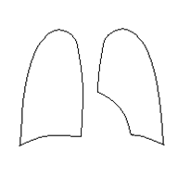
Lymphadenopathy:

RESPIRATORY SYSTEM:
Inspection: . . . . . . . . . . . . . . . . . . . . . . . . . . . . . . . . . . . . . . . . . . .
Palpation: . . . . . . . . . . . . . . . . . . . . . . . . . . . . . . . . . . . . . . . . . . .
Percussion: . . . . . . . . . . . . . . . . . . . . . . . . . . . . . . . . . . . . . . . . . . .
Auscultation
Breath sounds: Rales: Rhonchi
□ Vesicular □None □ None
□Bronchovesicular □Fine rales □ Fine rhonchi
□Bronchial □Coarse rales □Coarse rhonchi

CARDIOVASCULAR SYSTEM AND VASCULAR EXAMINATION:
Pulse rate: . . . . . /min (Regular/Irregular)
Pulse characteristics: . . . . . . . . . . . . . . . . . . . . . . . . . . . . . . . . . . . . . . . . . . . . . . . . . . . . . . . . . . . . . . . .
Brachial artery pressure Right: . . . . . . . / . . . . . . mmHg Left: . . . . . . . / . . . . . . mmHg
Femoral artery pressure Right: . . . . . . . / . . . . . . mmHg Left: . . . . . . . / . . . . . . mmHg

A. Radialis A. Carotis A. Subclavia A. Femoralis A. Poplitea A. Tib. Post. A. Dor. Ped.
Right . . . . . . . . . . . . . . . . . . . . . . . . . . . . . . . . . . . . . . . . . . . . . . . . . . . . . . . .
Left . . . . . . . . . . . . . . . . . . . . . . . . . . . . . . . . . . . . . . . . . . . . . . . . . . . . . . . .

Murmur: . . . . . . . . . . . . . . . . . . . . . . . . . . . . . . . . . . . . . . . . . . . . . . . . . . . . . . . .
Neck veins: . . . . . . . . . . . . . . . . . . . . . . . . . . . . . . . . . Hepatojugular reflux: . . . . . . . . . . . . . . . . . .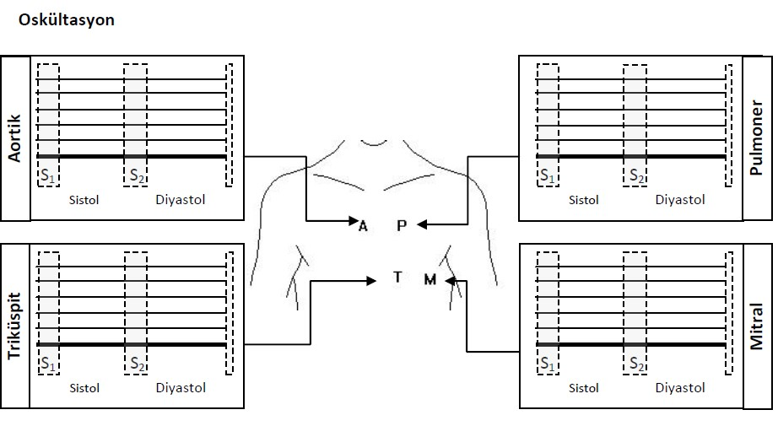

BREAST EXAMINATION
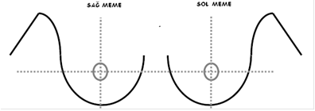
Inspection
Palpation:
Axillary examination (If a mass is detected on examination, please mark.)
GENITOURINARY SYSTEM:
Costovertebral angle tenderness: Right: . . . . . . . . . . . Left: . . . . . . . . . . . .
Globus vesicalis: . . . . . . . . . . . . . . . . . . . . . . . . . . . . . . . . . . . . . . . . . . . . . . . . . . . .
External genital organs
LOCOMOTOR SYSTEM:

NEUROLOGICAL SYSTEM:

GASTROINTESTINAL SYSTEM:
ABDOMINAL EXAMINATION (If a mass, hepatomegaly, or splenomegaly is detected on examination, please mark.)

Inspection:

Auscultation:

Palpation (tenderness, rebound, guarding) Percussion:
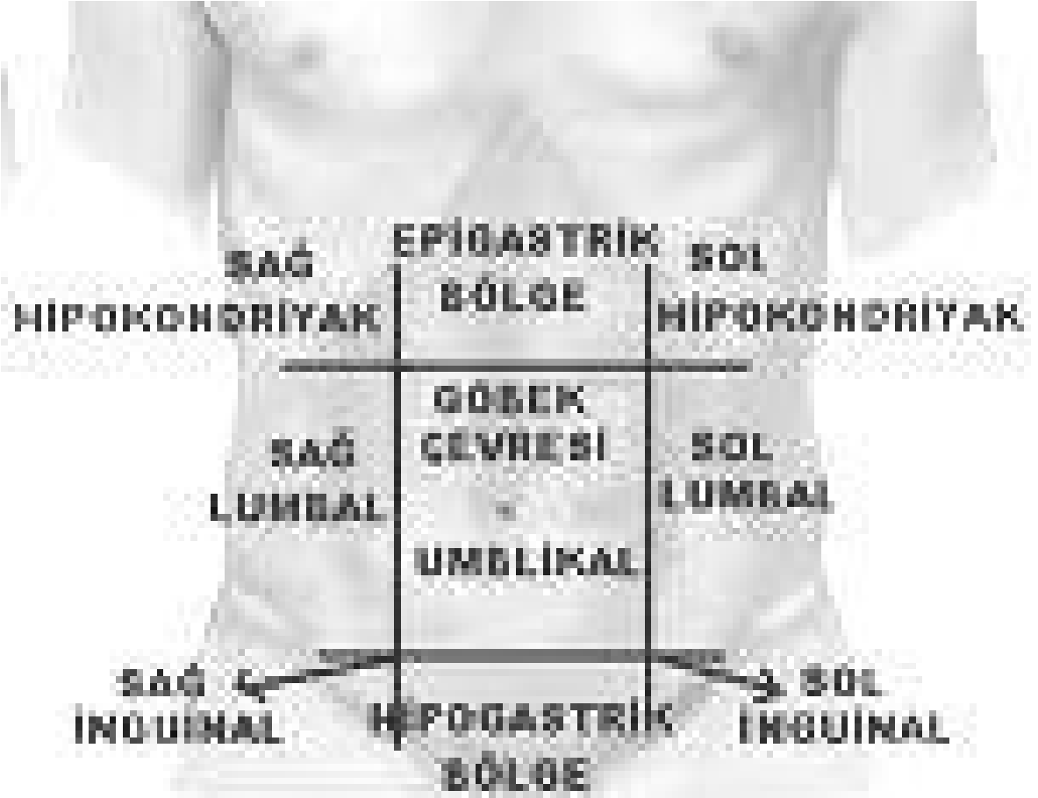
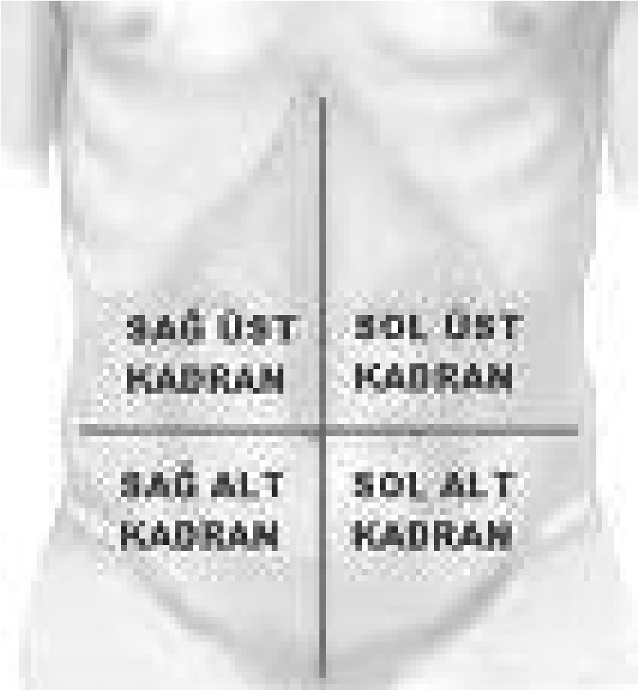

PRELIMINARY DIAGNOSES:

LABORATORY:
Complete blood count:
Urinalysis:
Biochemical tests:

ECG:
Imaging studies:

OTHER:

ASSESSMENT AND EVALUATION
Practical Assessment
ASSESSMENT IN ACCORDANCE WITH THE CLERKSHIP GUIDE
The clerkship guide has been prepared to ensure effective learning during the Internal Medicine Clinical Clerkship of Phase IV students at Yeditepe University Faculty of Medicine and to assess student performance during the clerkship. The maximum score for students is 100 points. Assessment is planned to be conducted in a total of 3 sections.
* If students receive points from procedures performed beyond the expected requirements, the maximum score cannot exceed 100 points. The grade obtained as a result of the evaluation of the student’s practical procedures performed in the Internal Medicine Clinics of Haydarpaşa Numune and Sancaktepe Training and Research Hospitals constitutes 10% of the clerkship passing grade.
INTERNAL MEDICINE CLERKSHIP PASSING GRADE
It is 50 points out of a total of 100 points. 40% of the written examination + 50% of the oral examination + 10% of the practical assessment grade constitute the clerkship passing grade.
YEAR 4 CLERKSHIP EVALUATION FORM
Full Name :
Student ID No. :
Clinic where the clerkship is completed :
Clerkship Start Date :
Clerkship End Date :
Repeat of Clerkship: yes ( ) no ( ) Which repeat (number): :
ON-CALL DATES: (Written approval must be obtained from the clinical education coordinator confirming that the student has completed at least 6 on-call duties during the clerkship.)
In words In numbers
Assigned Grade
Attendance to the clerkship:

Signature of the Faculty Member Responsible for Education :

